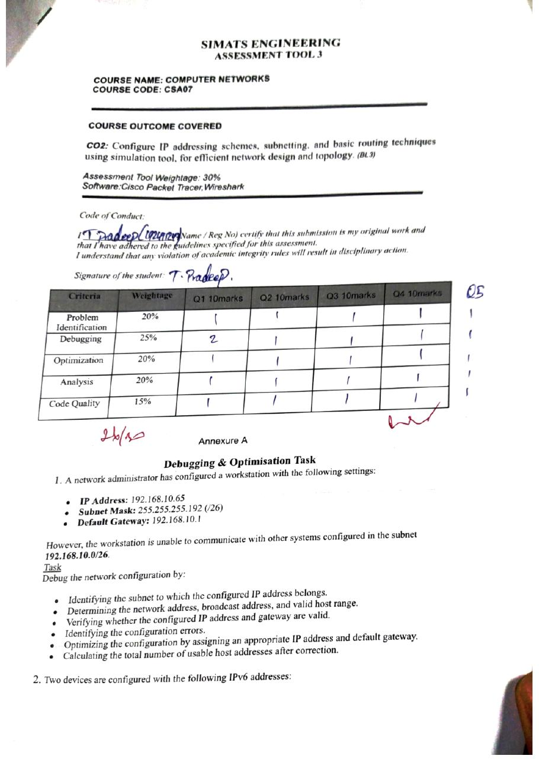
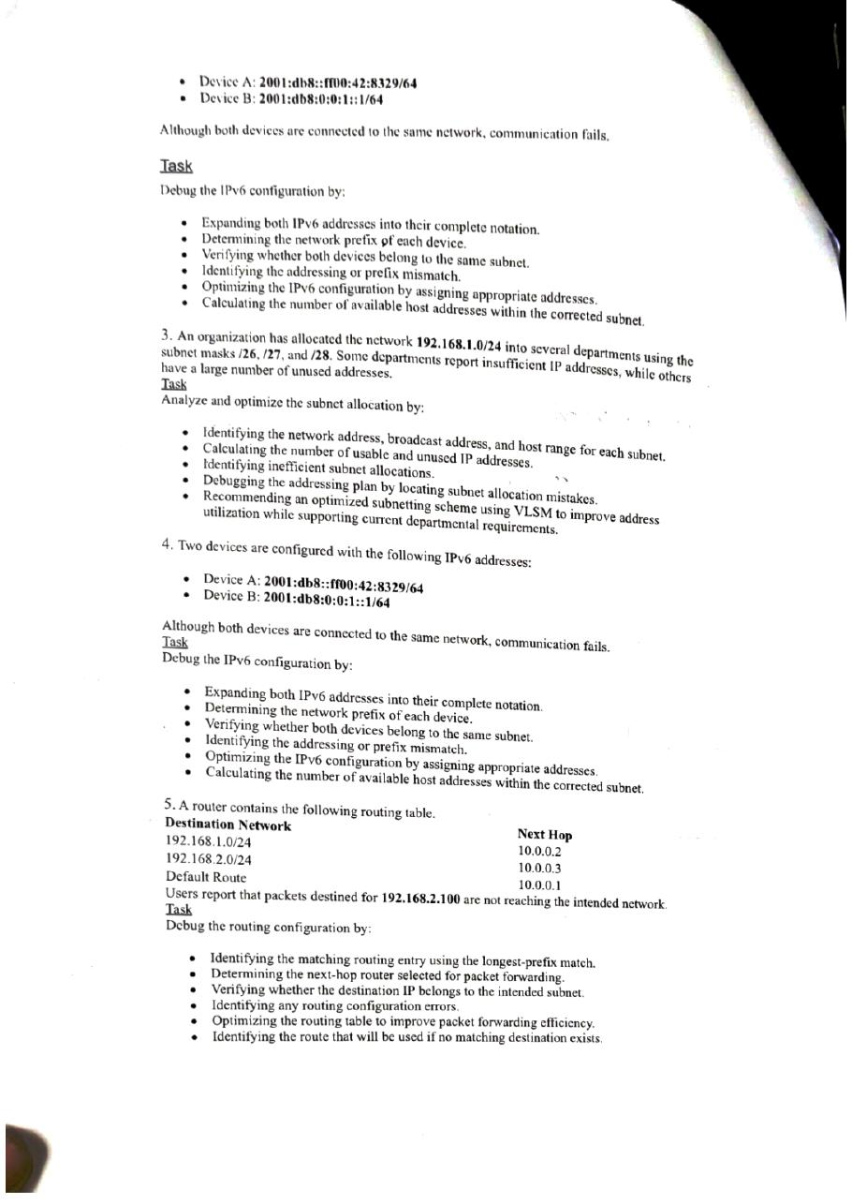
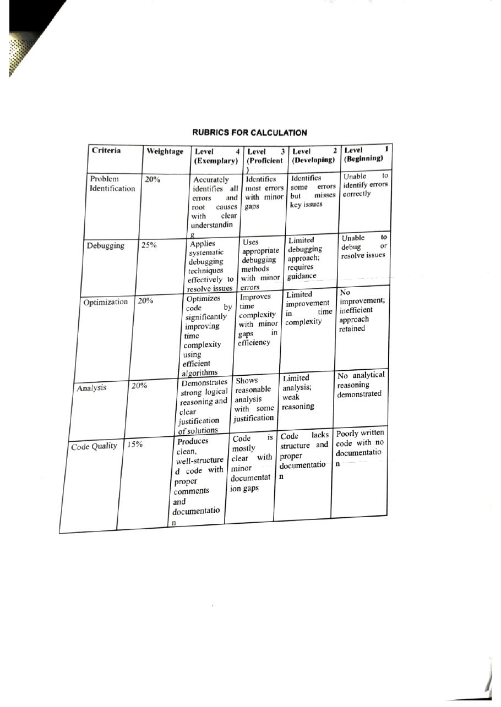

SIMATS ENGINEERING
ASSESSMENT TOOL 3

COURSE NAME: COMPUTER NETWORKS
COURSE CODE: CSA07

COURSE OUTCOME COVERED

CO2: Configure IP addressing schemes, subnetting, and basic routing techniques using simulation tool, for efficient network design and topology. (BL3)

Assessment Tool Weightage: 30%
Software:Cisco Packet Tracer,Wireshark

Code of Conduct:

I _______T. Pradeep(192411247)___(Name / Reg No) certify that this submission is my original work and that I have adhered to the guidelines specified for this assessment.
I understand that any violation of academic integrity rules will result in disciplinary action.

Signature of the student:T.Pradeep

Criteria | Weightage | Q1 10marks | Q2 10marks | Q3 10marks | Q4 10marks
Problem Identification | 20%
Debugging | 25%
Optimization | 20%
Analysis | 20%
Code Quality | 15%

Annexure A

Debugging & Optimisation Task
1. A network administrator has configured a workstation with the following settings:
- IP Address: 192.168.10.65
- Subnet Mask: 255.255.255.192 (/26)
- Default Gateway: 192.168.10.1
However, the workstation is unable to communicate with other systems configured in the subnet 192.168.10.0/26.
Task
Debug the network configuration by:
- Identifying the subnet to which the configured IP address belongs.
- Determining the network address, broadcast address, and valid host range.
- Verifying whether the configured IP address and gateway are valid.
- Identifying the configuration errors.
- Optimizing the configuration by assigning an appropriate IP address and default gateway.
- Calculating the total number of usable host addresses after correction.
Answer:
Given: Workstation IP = 192.168.10.65, mask = 255.255.255.192 (/26), default gateway = 192.168.10.1. The workstation cannot communicate with systems in 192.168.10.0/26. For /26 the block size is 256 − 192 = 64, so the subnets start at 0, 64, 128 and 192.
1. Identifying the subnet to which the configured IP address belongs.
Last octet of the IP: 65 = 01000001; last octet of the mask: 192 = 11000000.
65 AND 192 = 01000000 = 64 → the IP address belongs to subnet 192.168.10.64/26.
The other systems are in 192.168.10.0/26, which is a different subnet.
2. Determining the network address, broadcast address, and valid host range.
Subnet of the configured IP (192.168.10.64/26): network address = 192.168.10.64; broadcast = 64 + 64 − 1 = 127 → 192.168.10.127; valid hosts = 192.168.10.65 – 192.168.10.126.
Intended subnet (192.168.10.0/26): network address = 192.168.10.0; broadcast = 192.168.10.63; valid hosts = 192.168.10.1 – 192.168.10.62.
3. Verifying whether the configured IP address and gateway are valid.
IP address 192.168.10.65: it is a valid host address (the first usable host) of 192.168.10.64/26, but it is not inside 192.168.10.0/26, so it is not valid for the subnet the workstation must work in.
Gateway 192.168.10.1: 1 AND 192 = 0 → it belongs to 192.168.10.0/26. The workstation is in 192.168.10.64/26, so the gateway is not in the workstation's own subnet and cannot be reached directly. The gateway is therefore invalid for this workstation.
4. Identifying the configuration errors.
Error 1: the IP address is taken from the wrong block (192.168.10.64/26 instead of 192.168.10.0/26), so the workstation treats the other systems as being on a different network.
Error 2: the default gateway (192.168.10.1) is outside the workstation's subnet, so even traffic sent to the gateway cannot be delivered.
5. Optimizing the configuration by assigning an appropriate IP address and default gateway.
Choose a free address inside 192.168.10.0/26, excluding the gateway address: IP address = 192.168.10.2, subnet mask = 255.255.255.192, default gateway = 192.168.10.1.
Check: 2 AND 192 = 0 → network 192.168.10.0, the same as the gateway and the other systems, so direct communication and routing both work.
6. Calculating the total number of usable host addresses after correction.
Host bits = 32 − 26 = 6 → usable hosts = 2^6 − 2 = 64 − 2 = 62 (192.168.10.1 – 192.168.10.62).
The gateway uses 192.168.10.1, so 61 addresses remain for workstations.
Summary
Item | Before (wrong) | After (corrected)
IP address | 192.168.10.65 | 192.168.10.2
Subnet | 192.168.10.64/26 | 192.168.10.0/26
Network / broadcast | 192.168.10.64 / 192.168.10.127 | 192.168.10.0 / 192.168.10.63
Default gateway | 192.168.10.1 (outside subnet) | 192.168.10.1 (inside subnet)
Usable hosts | 62 | 62

2. Two devices are configured with the following IPv6 addresses:
- Device A: 2001:db8::ff00:42:8329/64
- Device B: 2001:db8:0:0:1::1/64
Although both devices are connected to the same network, communication fails.

Task
Debug the IPv6 configuration by:
- Expanding both IPv6 addresses into their complete notation.
- Determining the network prefix of each device.
- Verifying whether both devices belong to the same subnet.
- Identifying the addressing or prefix mismatch.
- Optimizing the IPv6 configuration by assigning appropriate addresses.
- Calculating the number of available host addresses within the corrected subnet.
Answer:
Given: Device A = 2001:db8::ff00:42:8329/64 and Device B = 2001:db8:0:0:1::1/64, both on the same network but unable to communicate. An IPv6 address has 8 groups of 16 bits; "::" stands for the missing zero groups. For /64, the network prefix is the first 4 groups and the last 4 groups are the interface ID.
1. Expanding both IPv6 addresses into their complete notation.
Device A: written groups = 2001, db8, ff00, 42, 8329 (5 groups), so "::" represents 8 − 5 = 3 zero groups → 2001:db8:0:0:0:ff00:42:8329 → padded: 2001:0db8:0000:0000:0000:ff00:0042:8329.
Device B: written groups = 2001, db8, 0, 0, 1, 1 (6 groups), so "::" represents 8 − 6 = 2 zero groups → 2001:db8:0:0:1:0:0:1 → padded: 2001:0db8:0000:0000:0001:0000:0000:0001.
2. Determining the network prefix of each device.
Device A: first 64 bits = 2001:0db8:0000:0000 → prefix 2001:db8::/64 (interface ID 0000:ff00:0042:8329).
Device B: first 64 bits = 2001:0db8:0000:0000 → prefix 2001:db8::/64 (interface ID 0001:0000:0000:0001).
3. Verifying whether both devices belong to the same subnet.
Both devices have the identical /64 prefix 2001:0db8:0000:0000, so they do belong to the same subnet, 2001:db8::/64.
4. Identifying the addressing or prefix mismatch.
There is no prefix mismatch in the addresses as written. The apparent problem is Device B's "1" in 2001:db8:0:0:1::1: it sits in the 5th group, which is part of the interface ID, not the subnet ID (the 4th group). It only looks like a different subnet.
Because the prefix and length (/64) agree, the failure must come from something other than subnet addressing: for example the devices are on different VLANs/links, an interface is down, or a firewall/ACL is blocking ICMPv6 and Neighbor Discovery.
The addressing is also unstructured (irregular interface IDs such as ff00:42:8329 and 1:0:0:1), which makes errors like this hard to spot.
5. Optimizing the IPv6 configuration by assigning appropriate addresses.
Use one clearly defined /64 for the link, with simple interface IDs: network 2001:db8:0:1::/64.
Device A = 2001:db8:0:1::a/64 and Device B = 2001:db8:0:1::b/64 (first 64 bits 2001:0db8:0000:0001 for both).
Verify with: ping 2001:db8:0:1::b from Device A, and make sure both devices are on the same VLAN/link and ICMPv6 is permitted.
6. Calculating the number of available host addresses within the corrected subnet.
Host bits = 128 − 64 = 64 → total addresses = 2^64 = 18,446,744,073,709,551,616. IPv6 has no broadcast address, so the "− 2" of IPv4 is not applied.
Summary
Item | Device A | Device B
Expanded address | 2001:0db8:0000:0000:0000:ff00:0042:8329 | 2001:0db8:0000:0000:0001:0000:0000:0001
Network prefix | 2001:db8::/64 | 2001:db8::/64
Same subnet? | Yes | Yes
Corrected address | 2001:db8:0:1::a/64 | 2001:db8:0:1::b/64
Hosts in /64 | 2^64 = 18,446,744,073,709,551,616 | 2^64 = 18,446,744,073,709,551,616

3. An organization has allocated the network 192.168.1.0/24 into several departments using the subnet masks /26, /27, and /28. Some departments report insufficient IP addresses, while others have a large number of unused addresses.
Task
Analyze and optimize the subnet allocation by:
- Identifying the network address, broadcast address, and host range for each subnet.
- Calculating the number of usable and unused IP addresses.
- Identifying inefficient subnet allocations.
- Debugging the addressing plan by locating subnet allocation mistakes.
- Recommending an optimized subnetting scheme using VLSM to improve address utilization while supporting current departmental requirements.
Answer
Given: Block 192.168.1.0/24 (256 addresses) is divided among departments using /26, /27 and /28. The question does not list the departments or their host counts, so the following assumptions are made to complete the analysis (replace them with your actual figures if different).
Assumption – existing plan: Department 1 = /26, Department 2 = /27, Department 3 = /28, allocated one after another.
Assumption – hosts required: Department 1 = 20 hosts, Department 2 = 50 hosts, Department 3 = 10 hosts.
1. Identifying the network address, broadcast address, and host range for each subnet.
Block sizes: /26 = 64, /27 = 32, /28 = 16.
Department 1 (/26): network 192.168.1.0; broadcast 0 + 64 − 1 = 63 → 192.168.1.63; hosts 192.168.1.1 – 192.168.1.62.
Department 2 (/27): starts at 64; network 192.168.1.64; broadcast 64 + 32 − 1 = 95 → 192.168.1.95; hosts 192.168.1.65 – 192.168.1.94.
Department 3 (/28): starts at 96; network 192.168.1.96; broadcast 96 + 16 − 1 = 111 → 192.168.1.111; hosts 192.168.1.97 – 192.168.1.110.
Department | Network | Host range | Broadcast
Dept 1 (/26) | 192.168.1.0 | 192.168.1.1 – 192.168.1.62 | 192.168.1.63
Dept 2 (/27) | 192.168.1.64 | 192.168.1.65 – 192.168.1.94 | 192.168.1.95
Dept 3 (/28) | 192.168.1.96 | 192.168.1.97 – 192.168.1.110 | 192.168.1.111

2. Calculating the number of usable and unused IP addresses.
Usable hosts = 2^(host bits) − 2: Dept 1 = 62, Dept 2 = 30, Dept 3 = 14.
Unused (spare) = usable − required: Dept 1 = 62 − 20 = 42 unused; Dept 2 = 30 − 50 = −20 (a shortage of 20 addresses); Dept 3 = 14 − 10 = 4 unused.
Unallocated addresses in the block: 192.168.1.112 – 192.168.1.255 = 144 addresses.
Department | Allocated | Usable | Required | Unused / (shortage)
Dept 1 (/26) | 192.168.1.0/26 | 62 | 20 | 42 unused
Dept 2 (/27) | 192.168.1.64/27 | 30 | 50 | 20 short
Dept 3 (/28) | 192.168.1.96/28 | 14 | 10 | 4 unused

3. Identifying inefficient subnet allocations.
Dept 1: the /26 is far too large for 20 hosts, so 42 of 62 usable addresses (about 68%) are wasted.
Dept 2: the /27 gives only 30 usable addresses for 50 hosts, so it is insufficient by 20 addresses.
Dept 3: the /28 fits well (10 of 14 used, about 71% utilization).
In addition, 144 addresses of the /24 are not allocated at all.
4. Debugging the addressing plan by locating subnet allocation mistakes.
Mistake 1: the subnet sizes were assigned in a fixed order (/26, /27, /28) without matching them to the departments' host requirements: the largest block went to the department needing only 20 hosts, and the department needing 50 hosts got a /27.
Mistake 2: no VLSM planning (largest requirement first), so one subnet is oversized while another is undersized.
Mistake 3: no growth margin or reserved block was planned for router links or new departments.
5. Recommending an optimized subnetting scheme using VLSM.
Sort by requirement (largest first) and choose the smallest block with 2^n − 2 ≥ hosts: 50 hosts → /26 (62); 20 hosts → /27 (30); 10 hosts → /28 (14).
Allocate: Dept 2 (50 hosts) → 192.168.1.0/26; Dept 1 (20 hosts) → 192.168.1.64/27; Dept 3 (10 hosts) → 192.168.1.96/28. The same three masks are used, but they are now matched to the right departments.
The remaining 192.168.1.112 – 192.168.1.255 (144 addresses) stays free for growth; for example 192.168.1.112/30 can be kept for a router-to-router link (hosts .113 – .114).
Department | Hosts needed | Subnet | Host range | Broadcast | Utilization
Dept 2 | 50 | 192.168.1.0/26 | 192.168.1.1 – .62 | 192.168.1.63 | 50/62 = 81%
Dept 1 | 20 | 192.168.1.64/27 | 192.168.1.65 – .94 | 192.168.1.95 | 20/30 = 67%
Dept 3 | 10 | 192.168.1.96/28 | 192.168.1.97 – .110 | 192.168.1.111 | 10/14 = 71%

4. Two devices are configured with the following IPv6 addresses:
- Device A: 2001:db8::ff00:42:8329/64
- Device B: 2001:db8:0:0:1::1/64
Although both devices are connected to the same network, communication fails.
Task
Debug the IPv6 configuration by:
- Expanding both IPv6 addresses into their complete notation.
- Determining the network prefix of each device.
- Verifying whether both devices belong to the same subnet.
- Identifying the addressing or prefix mismatch.
- Optimizing the IPv6 configuration by assigning appropriate addresses.
- Calculating the number of available host addresses within the corrected subnet.
Answer:
Given: Device A = 2001:db8::ff00:42:8329/64 and Device B = 2001:db8:0:0:1::1/64, both on the same network but unable to communicate. An IPv6 address has 8 groups of 16 bits; "::" stands for the missing zero groups. For /64, the network prefix is the first 4 groups and the last 4 groups are the interface ID.
Note: Question 4 is identical to Question 2, so the same analysis and result apply.
1. Expanding both IPv6 addresses into their complete notation.
Device A: written groups = 2001, db8, ff00, 42, 8329 (5 groups), so "::" represents 8 − 5 = 3 zero groups → 2001:db8:0:0:0:ff00:42:8329 → padded: 2001:0db8:0000:0000:0000:ff00:0042:8329.
Device B: written groups = 2001, db8, 0, 0, 1, 1 (6 groups), so "::" represents 8 − 6 = 2 zero groups → 2001:db8:0:0:1:0:0:1 → padded: 2001:0db8:0000:0000:0001:0000:0000:0001.
2. Determining the network prefix of each device.
Device A: first 64 bits = 2001:0db8:0000:0000 → prefix 2001:db8::/64 (interface ID 0000:ff00:0042:8329).
Device B: first 64 bits = 2001:0db8:0000:0000 → prefix 2001:db8::/64 (interface ID 0001:0000:0000:0001).
3. Verifying whether both devices belong to the same subnet.
Both devices have the identical /64 prefix 2001:0db8:0000:0000, so they do belong to the same subnet, 2001:db8::/64.
4. Identifying the addressing or prefix mismatch.
There is no prefix mismatch in the addresses as written. The apparent problem is Device B's "1" in 2001:db8:0:0:1::1: it sits in the 5th group, which is part of the interface ID, not the subnet ID (the 4th group). It only looks like a different subnet.
Because the prefix and length (/64) agree, the failure must come from something other than subnet addressing: for example the devices are on different VLANs/links, an interface is down, or a firewall/ACL is blocking ICMPv6 and Neighbor Discovery.
The addressing is also unstructured (irregular interface IDs such as ff00:42:8329 and 1:0:0:1), which makes errors like this hard to spot.
5. Optimizing the IPv6 configuration by assigning appropriate addresses.
Use one clearly defined /64 for the link, with simple interface IDs: network 2001:db8:0:1::/64.
Device A = 2001:db8:0:1::a/64 and Device B = 2001:db8:0:1::b/64 (first 64 bits 2001:0db8:0000:0001 for both).
Verify with: ping 2001:db8:0:1::b from Device A, and make sure both devices are on the same VLAN/link and ICMPv6 is permitted.
6. Calculating the number of available host addresses within the corrected subnet.
Host bits = 128 − 64 = 64 → total addresses = 2^64 = 18,446,744,073,709,551,616. IPv6 has no broadcast address, so the "− 2" of IPv4 is not applied.
Summary
Item | Device A | Device B
Expanded address | 2001:0db8:0000:0000:0000:ff00:0042:8329 | 2001:0db8:0000:0000:0001:0000:0000:0001
Network prefix | 2001:db8::/64 | 2001:db8::/64
Same subnet? | Yes | Yes
Corrected address | 2001:db8:0:1::a/64 | 2001:db8:0:1::b/64
Hosts in /64 | 2^64 = 18,446,744,073,709,551,616 | 2^64 = 18,446,744,073,709,551,616

5. A router contains the following routing table.
Destination Network | Next Hop
192.168.1.0/24 | 10.0.0.2
192.168.2.0/24 | 10.0.0.3
Default Route | 10.0.0.1
Users report that packets destined for 192.168.2.100 are not reaching the intended network.
Task
Debug the routing configuration by:
- Identifying the matching routing entry using the longest-prefix match.
- Determining the next-hop router selected for packet forwarding.
- Verifying whether the destination IP belongs to the intended subnet.
- Identifying any routing configuration errors.
- Optimizing the routing table to improve packet forwarding efficiency.
- Identifying the route that will be used if no matching destination exists.
Answer:
Given: Routing table: 192.168.1.0/24 → next hop 10.0.0.2; 192.168.2.0/24 → next hop 10.0.0.3; default route → next hop 10.0.0.1. Packets for 192.168.2.100 do not reach the intended network. The router chooses the matching entry with the longest prefix.
1. Identifying the matching routing entry using the longest-prefix match.
192.168.1.0/24: 192.168.2.100 AND 255.255.255.0 = 192.168.2.0 ≠ 192.168.1.0 → no match.
192.168.2.0/24: 192.168.2.100 AND 255.255.255.0 = 192.168.2.0 = 192.168.2.0 → match (24 bits).
Default route 0.0.0.0/0: matches every address, but only with 0 bits.
The longest prefix is /24, so the selected entry is 192.168.2.0/24.
2. Determining the next-hop router selected for packet forwarding.
The selected entry 192.168.2.0/24 points to next hop 10.0.0.3, so the packet is forwarded to 10.0.0.3.
3. Verifying whether the destination IP belongs to the intended subnet.
Subnet 192.168.2.0/24 covers 192.168.2.0 – 192.168.2.255 (valid hosts 192.168.2.1 – 192.168.2.254, broadcast 192.168.2.255).
192.168.2.100 lies in this range, so it belongs to the intended subnet.
4. Identifying any routing configuration errors.
The route lookup itself is correct: the table as written selects the right entry (192.168.2.0/24) for 192.168.2.100, so the fault is not a wrong destination prefix or mask.
The problem must therefore be with the forwarding path after the match. Likely causes: (a) the next hops may be wrong or swapped, i.e. 10.0.0.3 is not the router that actually leads to 192.168.2.0/24; (b) 10.0.0.3 is down/unreachable, or has no route back or a route to 192.168.2.0/24; (c) the entries list only a next hop and no exit interface, so reachability of 10.0.0.x is not guaranteed; (d) an ACL/firewall is blocking the traffic.
Check with: show ip route 192.168.2.100, ping 10.0.0.3, traceroute 192.168.2.100 and a Wireshark capture on the link to 10.0.0.3.
5. Optimizing the routing table to improve packet forwarding efficiency.
Keep the two specific /24 routes: they cannot be summarized (for example into 192.168.0.0/22) because they use different next hops, and a summary would also cover 192.168.0.0/24 and 192.168.3.0/24 unnecessarily.
Verify and correct the next-hop addresses, and add the exit interface to each static route so the next hop is resolved reliably.
Keep a single default route (0.0.0.0/0 via 10.0.0.1) as the gateway of last resort; the table then needs only three entries.
6. Identifying the route that will be used if no matching destination exists.
If the destination matches neither 192.168.1.0/24 nor 192.168.2.0/24, the default route 0.0.0.0/0 is used and the packet is forwarded to next hop 10.0.0.1.
Summary
Item | Result
Matching entry for 192.168.2.100 | 192.168.2.0/24 (longest prefix, /24)
Next hop selected | 10.0.0.3
Destination in intended subnet? | Yes (192.168.2.0/24)
Routing error | None in the lookup; verify the next hop / path (see task 4)
Route if no match | Default route 0.0.0.0/0 via 10.0.0.1

RUBRICS FOR CALCULATION

Criteria | Weightage | Level 4 (Exemplary) | Level 3 (Proficient) | Level 2 (Developing) | Level 1 (Beginning)
Problem Identification | 20% | Accurately identifies all errors and root causes with clear understanding | Identifies most errors with minor gaps | Identifies some errors but misses key issues | Unable to identify errors correctly
Debugging | 25% | Applies systematic debugging techniques effectively to resolve issues | Uses appropriate debugging methods with minor errors | Limited debugging approach; requires guidance | Unable to debug or resolve issues
Optimization | 20% | Optimizes code by significantly improving time complexity using efficient algorithms | Improves time complexity with minor gaps in efficiency | Limited improvement in time complexity | No improvement; inefficient approach retained
Analysis | 20% | Demonstrates strong logical reasoning and clear justification of solutions | Shows reasonable analysis with some justification | Limited analysis; weak reasoning | No analytical reasoning demonstrated
Code Quality | 15% | Produces clean, well-structured code with proper comments and documentation | Code is mostly clear with minor documentation gaps | Code lacks structure and proper documentation | Poorly written code with no documentation

